H.T No
Regulations:
A19

Sreenidhi Institute of Science and Technology
(An Autonomous Institution)
Code No: 7W104 Date: 12-Oct-2020 (FN)

M.Tech I-Year I-Semester External Examination, October - 2020 (Supplementary)
ADVANCED MECHANICS OF SOLIDS (CAD/CAM)

Time: 2 Hours Max.Marks:70

Note: a) No additional answer sheets will be provided.
b) All sub-parts of a question must be answered at one place only, otherwise it will not be valued.
c) Missing data can be assumed suitably.

ANSWER ANY 5 OUT OF 8 QUESTIONS. EACH QUESTION CARRIES 14 MARKS.

1. | a) | With the help of a neat sketch, state Maxwell’s reciprocal theorem. | [7M]
 | b) | By using Castigliano’s theorem, calculate vertical deflection at the middle of a simply supported beam which carries a UDL of intensity W over the full span. | [7M]
2. | a) | Find the value of load P in Fig.1, so that the maximum bending stress allowed is 15MPa for the case of beam shown below, subjected to unsymmetrical bending.  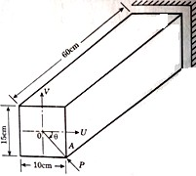 | [7M]
 | b) | A simply supported beam of length 1.8m carries a central load of 3.5kN inclined at 30⁰ to the vertical and passing through the centroid of the section as shown in fig.2. The thickness is 10mm throughout the section.  Determine  i) maximum tensile stress  ii) maximum compressive stress and  iii) deflection due to the load. All dimensions are in mm.  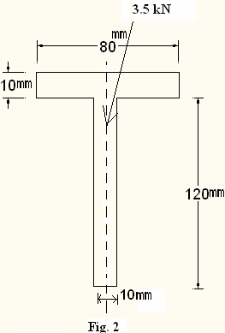 | [7M]
3. | a) | Derive Winkler-Bach formula for the given curved beam from first principles. Also sketch stress distribution across the depth of the section. | [7M]
 | b) | Explain the procedure to calculate contact stresses when two bodies (sphere and sphere) in contact. | [7M]
4. | a) | Use Prandtl’s method to derive equation for the components of stress, the maximum value of resultant stress and torsional rigidity of a prismatic bar with elliptic cross-section. | [7M]
 | b) | The aluminum (G=27.1GPa) hollow thin walled torsion member has shown dimensions in Fig.2. Its length is 3m. If the member is subjected torque of 11KN-m, determine the maximum shear stress and angle of twist.  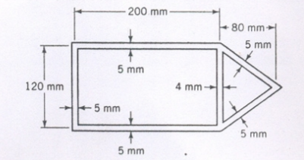 | [7M]
5. | a) | Explain the concept of buckling? Derive an expression when the column is fixed with one end and the other end is hinged. | [7M]
 | b) | Write a brief note on Eigen-value problem, in the treatment of column buckling. | [7M]
6. | a) | Design the considerations: K as a failure criterion, J-integral as a fracture criterion. | [7M]
 | b) | Differentiate between LEFM and EPFM. | [7M]
7. | a) | Differentiate between determinate and indeterminate structures with a neat sketch. | [7M]
 | b) | List out the assumptions on which a solution for contact stresses is based. | [7M]
8. | a) | How the properties of a materials effects on beams? | [7M]
 | b) | Explain how the hollow thin wall is affected by twisting moment? | [7M]

-- 00 -- 00 –

